**Aplikasi Satgas Covid**

**Tugas Rancang Pemrograman Desktop**



Disusun oleh :

|  |  |
| --- | --- |
| Bartolomeus Bima Santoso | 672018064 |
| Mutiara Posumah | 672018262 |
| Yohan’s Banjarnahor | 672018356 |

**Program Studi Teknik Informatika**

**Fakultas Teknologi Informasi**

**Universitas Kristen Satya Wacana**

**Salatiga**

**2021**

# Daftar Isi

# BAB I

# Pendahuluan

## Latar Belakang

## BPMN (Proses Bisnis)

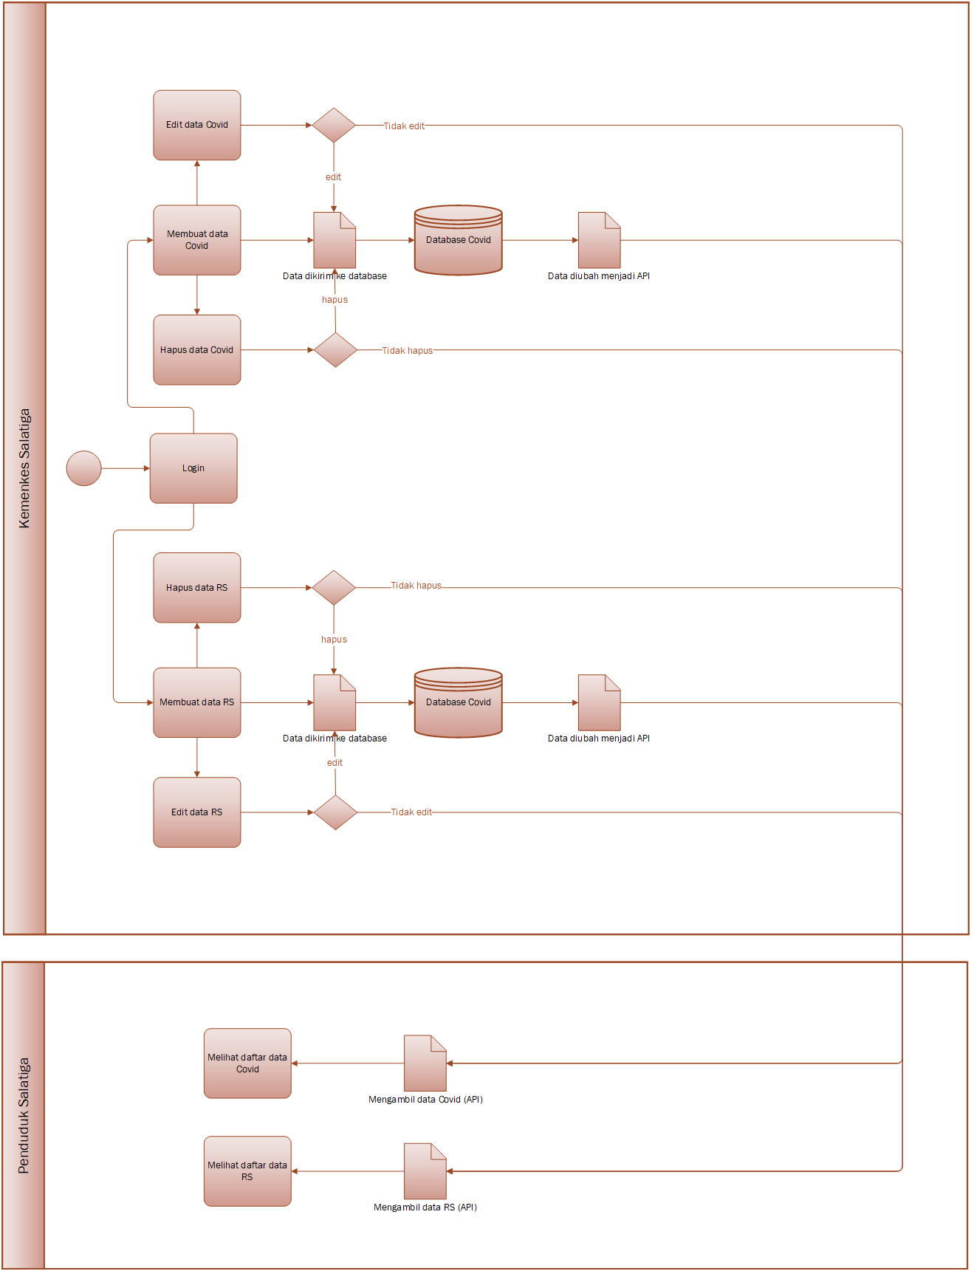

# BAB II

# Deskripsi Keseluruhan

## Unified Modelling Language (UML)

1. **Use Case**

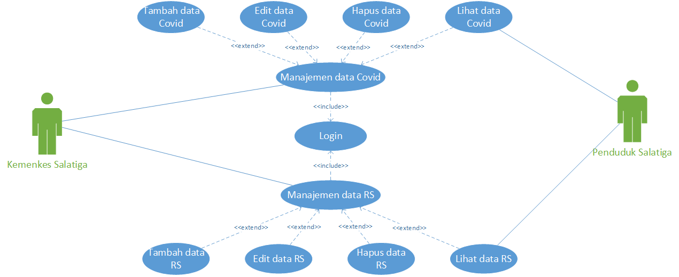

1. **Activity Diagram**

* **Activity Kemenkes Salatiga Manajemen Data Covid**

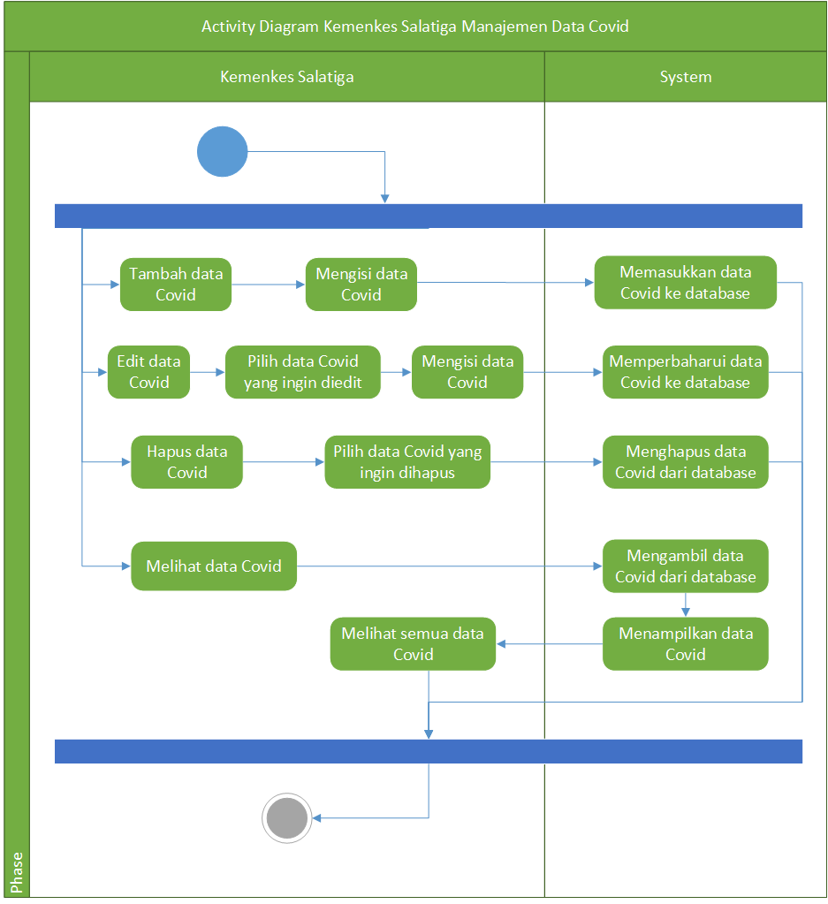

* **Activity Kemenkes Salatiga Manajemen Data Rumah Sakit**

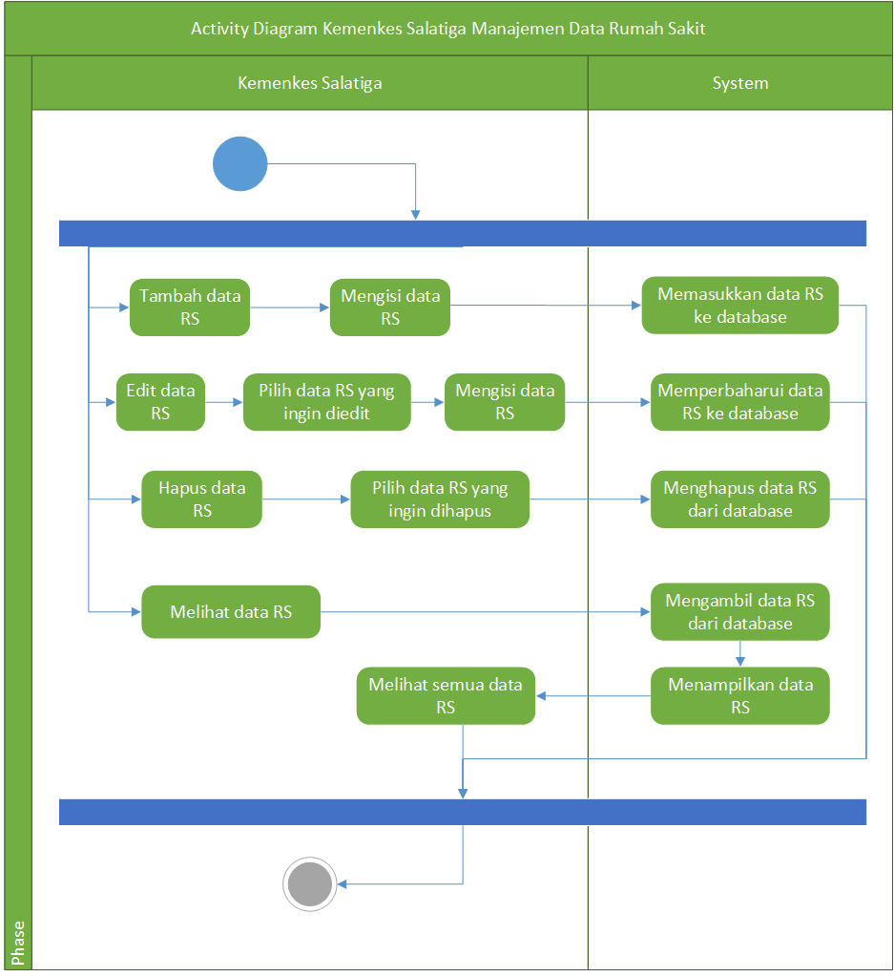

* **Activity Penduduk Salatiga Melihat Data Covid**

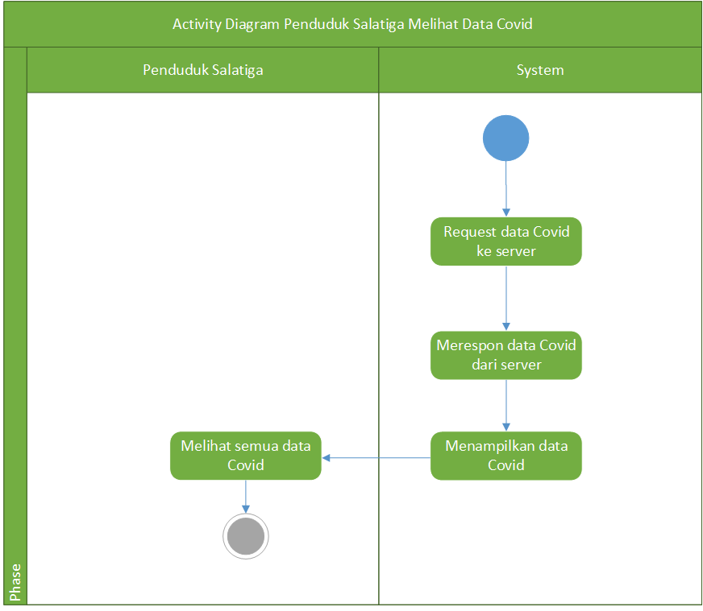

* **Activity Penduduk Salatiga Melihat Data Rumah Sakit**

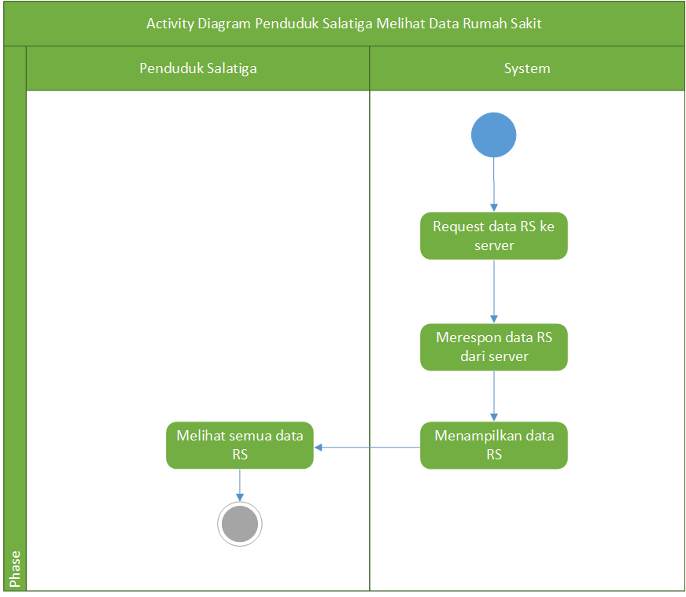

1. **ERD**

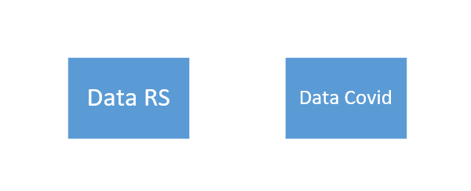

1. **Timetable**

|  |  |  |  |  |  |
| --- | --- | --- | --- | --- | --- |
| **No.** | **Kegiatan** | **Minggu ke-** | | | |
| **1** | **2** | **3** | **4** |
| **1.** | Requirement |  |  |  |  |
| **2.** | Front-end & Back-end |  |  |  |  |
| **3.** | Testing |  |  |  |  |